**SOFTWARE DESIGN DOCUMENT(SDD)**

**Smart Ticket & Issue Management System**

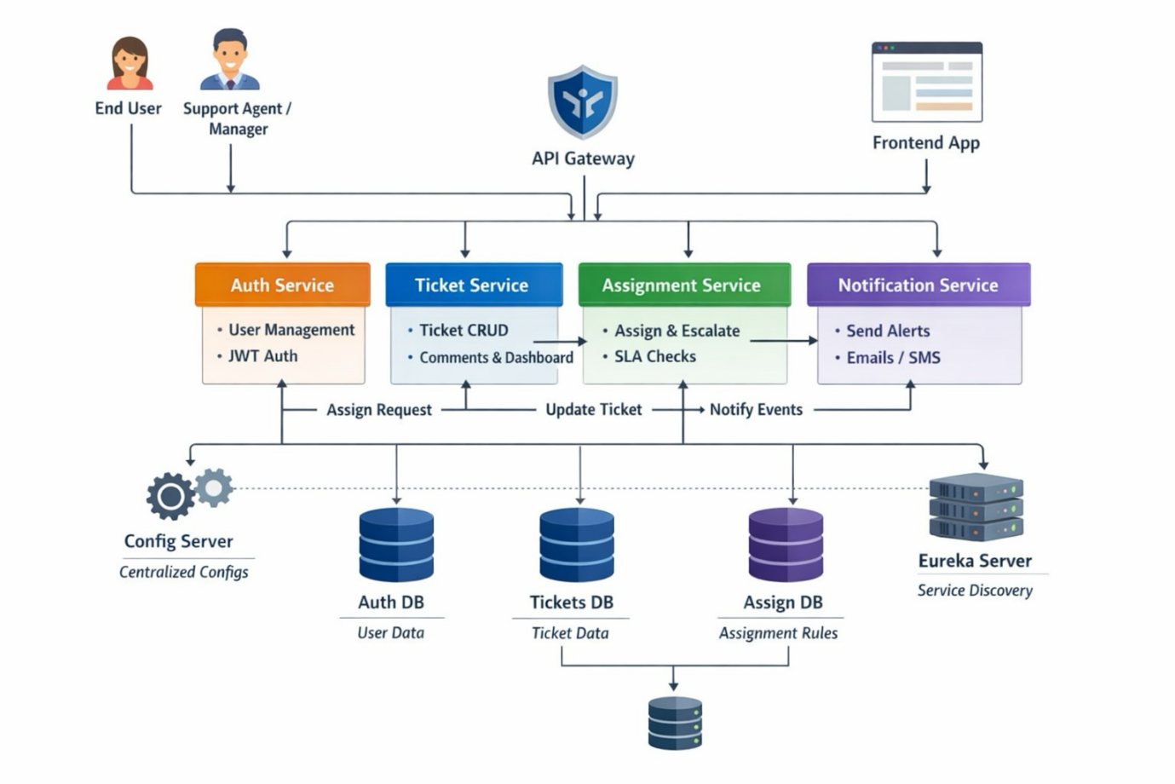

**1. DOCUMENT CONTROL**

| **Item** | **Details** |
| --- | --- |
| Project Name | Smart Ticket & Issue Management System |
| Version | 1.0 |
| Author | (Your Name) |
| Date | (Date) |
| Status | Final |

**2. PURPOSE OF THE DOCUMENT**

This document describes the **system architecture, design decisions, component structure, APIs, data models, and non-functional aspects** of the Smart Ticket & Issue Management System.

It is intended for:

* Developers
* Reviewers
* Interview discussions
* Maintenance & enhancement planning

**3. SYSTEM OVERVIEW**

**Business Objective**

Provide a scalable, secure, and maintainable system to:

* Manage Users & Identities
* Handle Ticket Lifecycle
* Ticket Allocation
* Support growth through microservices

**High-Level Features**

* User Registration & Secure Login
* Real-time Ticket Tracking
* Role-based access (USER / ADMIN / Manager / Agent)

**4. ARCHITECTURE OVERVIEW (HLD)**

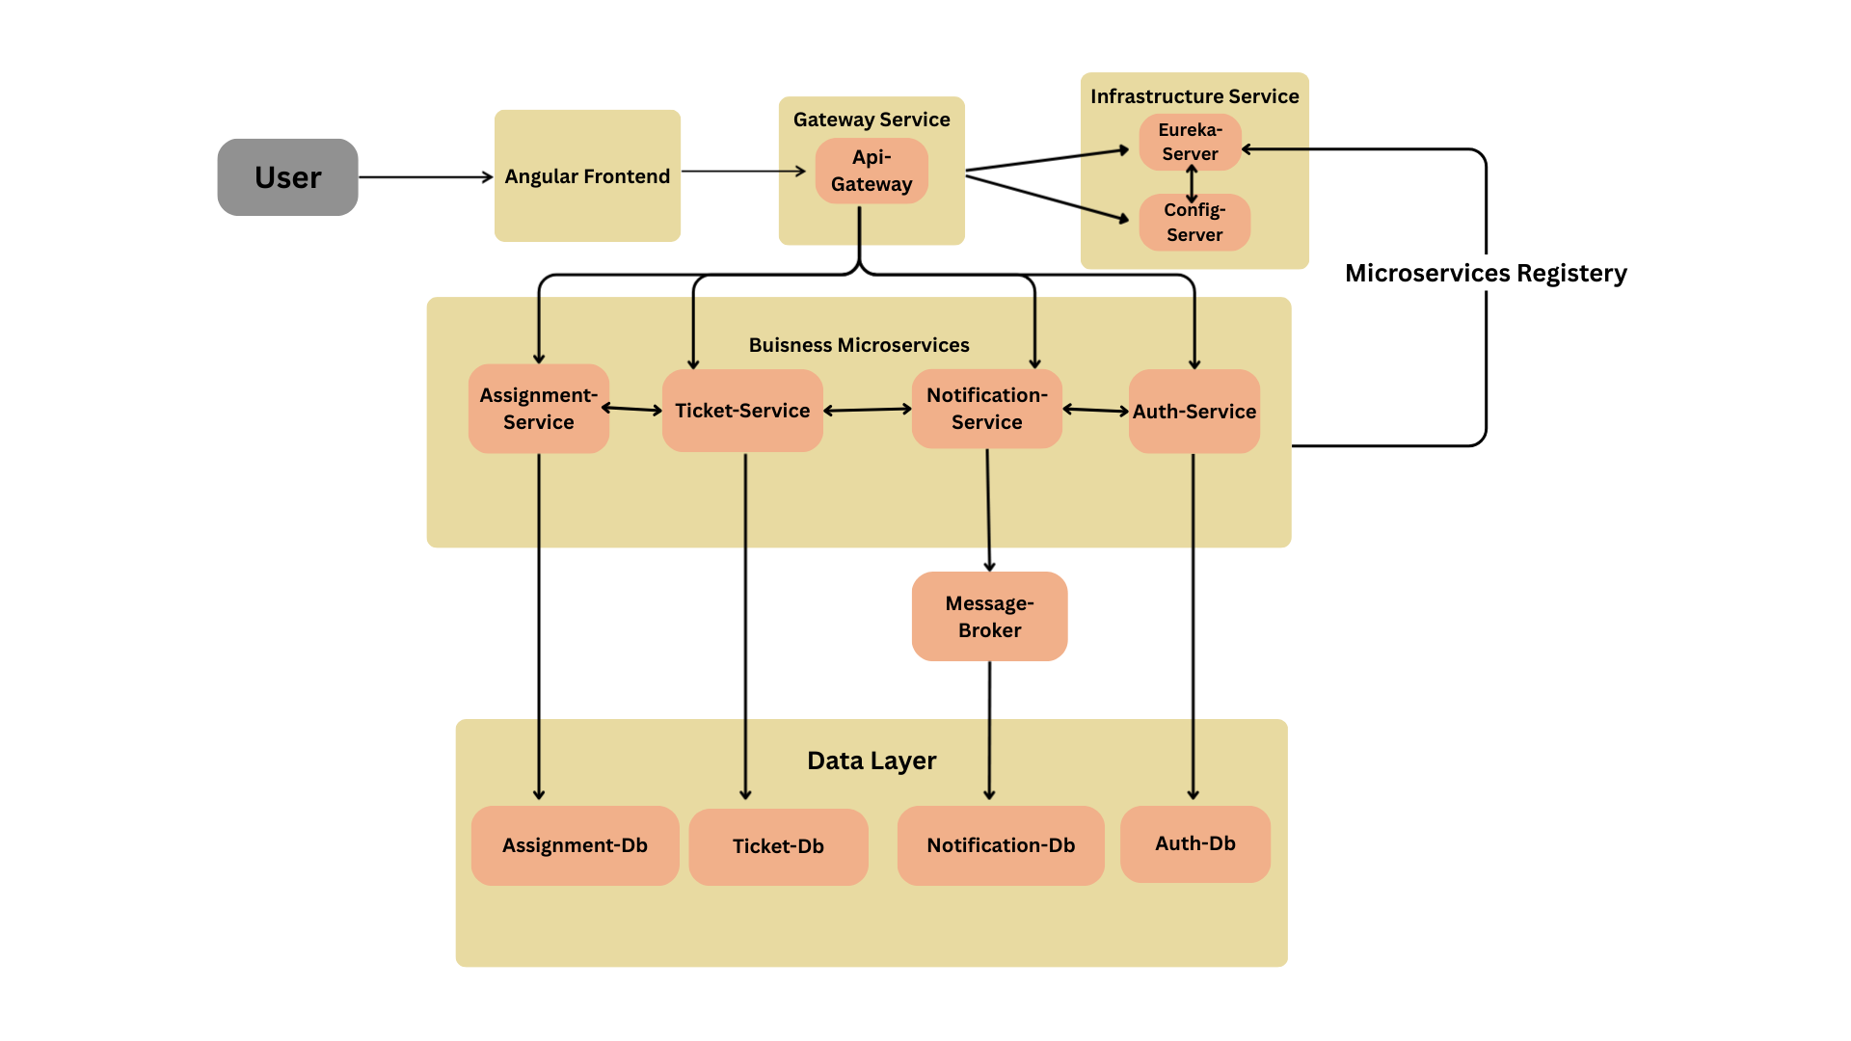

**Architecture Style**

* Microservices Architecture
* REST-based communication
* Containerized deployment

**Core Components**

1. Angular Frontend
2. API Gateway (optional)
3. User Service
4. Product Service
5. Order Service
6. MongoDB (per service)
7. CI/CD Pipeline

**5. TECHNOLOGY STACK**

**Backend**

* Java 17
* Spring Boot
* Spring Web
* Spring Data MongoDB
* Spring Validation

**Frontend**

* Angular
* Angular Material
* RxJS

**Database**

* MongoDB (one DB per microservice)

**DevOps**

* Docker
* Docker Compose
* Jenkins
* SonarQube

**Testing**

* JUnit 5
* Mockito
* Spring Boot Test

**6. MICROSERVICES DESIGN**

**6.1 Auth Service**

**Responsibilities**

* User registration
* Authentication
* Role management

**APIs**

POST /auth/register

POST /auth/login

POST /auth/admin/register

GET /auth/getAll

**Database**

* users table

**6.2 Ticket Service**

**Responsibilities**

* Ticket CRUD
* Lifecycle Management
* Reopen/Cancel
* History/Activity Logs
* Comments
* Dashboard

**APIs**

POST /tickets

GET /tickets

GET /tickets/{id}

PUT /tickets/{id} (for updating status)

DELETE /tickets/{id}

GET /tickets/user/{userId}

POST /tickets/{id}/reopen (Reopen resolved/closed ticket)

GET /tickets/dashboard/summary

GET /tickets/dashboard/agent

**Database**

* Ticket collection

**6.3 Assignment Service**

**Responsibilities**

* Assignment of Tickets
* Priority Decision
* SLA Rules

**APIs**

POST /api/assign/{ticketId}

GET /api/escalations/manager/{mgrId}

GET /api/agents/workload

GET /api/escalations/logs

GET /api/agent/{agentId}

**Database**

* assignment table

**6.4 Notification Service**

**Responsibilities**

* Sends notifications

**APIs**

POST /notify/ticket-created

POST /notify/ticket-assigned

POST /notify/sla-breach

**Database**

* notification collection

**6.5 Api Gateway**

**Responsibilities**

* forwarding api points

**7. DATA DESIGN (LLD)**

**User Document**

{

"email": "user@test.com",

"password": "encrypted",

"role": "USER",

"active": true

}

POST /admin/register

{

"name": "Agent X",

"email": "agent@gmail.com",

"password": encrypted,

"role": "ROLE_AGENT"

"active": true

}

**Ticket Document**

{

"id": "p201",

"title": "Phone",

"description":"",

"category":"",

"priority":"",

"status": "",

"created_at": "",

"updated_at":"",

"due_date":"",

"user_id":"",

"assigned_agent_id",

"attachments":

[ { "fileName": "error_log.docx",

"fileUrl": "/storage/tickets/file_uuid.docx",

"fileType": "application/vnd.openxmlformats-officedocument",

"uploadedAt": "2025-08-03T10:00:00Z" }

],

"comments": [ { "authorId": "mysql_user_id_456",

"text": "Checking logs now.",

"isInternal": true,

"timestamp": "ISODate" }

]

}

**Assignment Document**

{

"assignmentId": "assgn_8821",

"ticketId": "T-1000",

“agentId”:”agent_1”,

“assignedBy”:”manager_1”,

“assignedAt”:”Time Stamp”,

“priority”:”HIGH”,

“sla”:{

“responseTimeLimit”:”Time Stamp”,

“resolutionTimeLimit”:”TIme STamp”,

“isEscalated”:boolean

},

“status”:”ACTIVE/INACTIVE”

}

**Notification Document**

{

"id": "N1001",

“user_id”:”1234”,

“ticketId”:”1233”,

“Type”:”is assignmed”,

“Status”:”pending/closed/created/failed”

"emailId": "abc@gmail.com",

"description":"",

"created_at": "Time Stamp",

}

**8. API DESIGN & VALIDATION**

* RESTful principles
* JSON request/response
* Bean Validation at DTO layer
* Service-level business rule enforcement
* Standard HTTP status codes

**9. ERROR HANDLING STRATEGY**

**Global Exception Handling**

* Centralized using @ControllerAdvice
* Standard error response format

{

"timestamp": "TimeStamp",

"status": 400,

"error": "Validation Error",

"message": "Invalid Ticket Data"

}

**10. SECURITY DESIGN**

* Password encryption (BCrypt)
* Role-based access control
* JWT authentication
* Secure API access

**11. NON-FUNCTIONAL REQUIREMENTS**

| **Area** | **Design Decision** |
| --- | --- |
| Scalability | Stateless services, Docker |
| Performance | Pagination, async calls |
| Availability | Independent services |
| Maintainability | POM-like layered backend |
| Security | Validation, encryption |
| Observability | Logging & monitoring |

**12. TESTING STRATEGY**



**Backend**

* Unit tests (Service layer)
* Controller tests (MockMvc)
* Minimum 90% coverage

**Frontend**

* Component tests
* Service tests

**Quality Gates**

* SonarQube enforced
* Build fails on violations

**13. CI/CD DESIGN**





**Pipeline Flow**

1. Git Commit
2. Jenkins Build
3. Unit Tests
4. SonarQube Scan
5. Quality Gate Check
6. Docker Build
7. Docker Compose Deploy

**14. DEPLOYMENT DESIGN**

* Docker image per microservice
* docker-compose for orchestration
* Environment-specific configs

**15. ASSUMPTIONS & CONSTRAINTS**

**Assumptions**

* Services communicate over REST
* MongoDB available
* Docker environment present

**Constraints**

* No distributed transactions
* Event-driven architecture out of scope

**16. FUTURE ENHANCEMENTS**

* Spring Cloud Gateway
* Kafka-based async communication
* Kubernetes deployment
* Centralized logging (ELK)

**17. CONCLUSION**

This design ensures:  
✔ Clean separation of concerns  
✔ Scalability & maintainability  
✔ Testability & CI/CD readiness  
✔ Interview-ready explanation

**SEQUENCE DIAGRAMS**

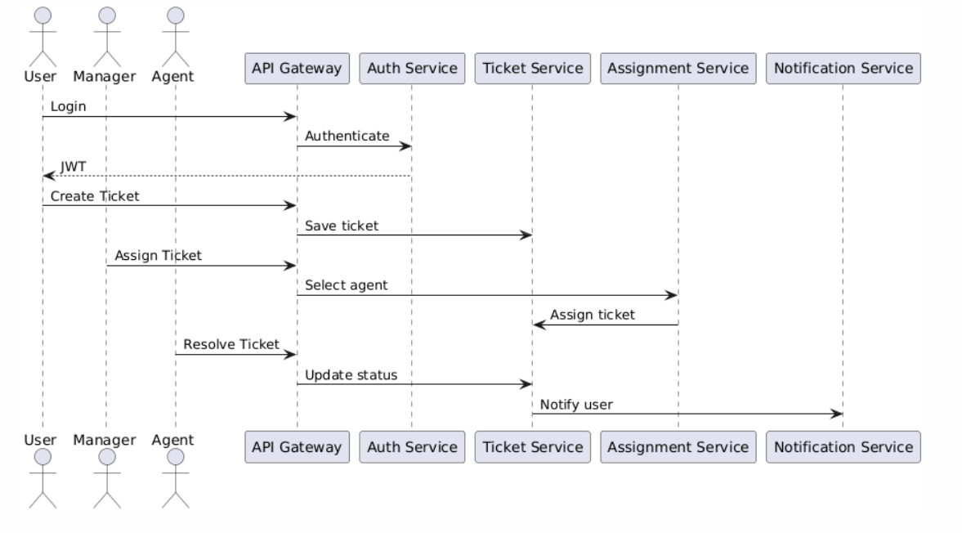

User Login Flow -

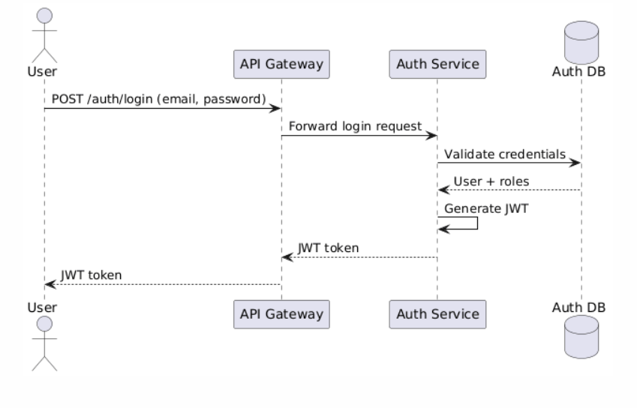

Ticket Creation -

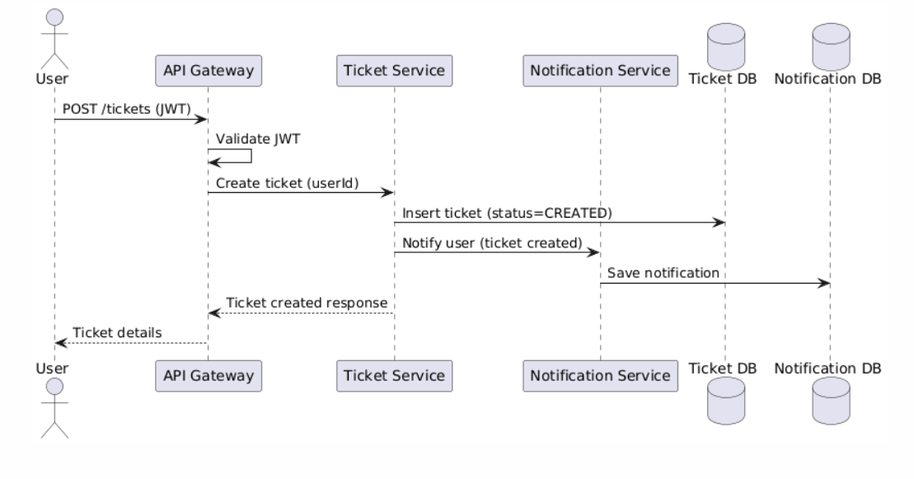

Manager Assigns Ticket to Agent -

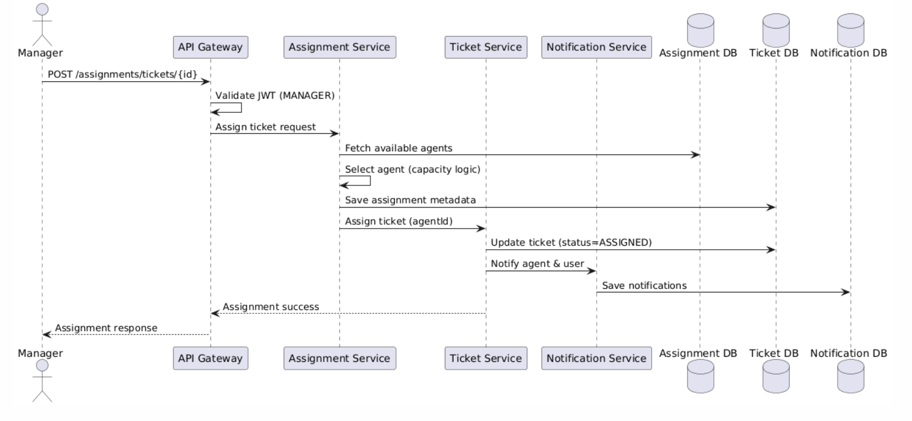

Agent Resolves Ticket -

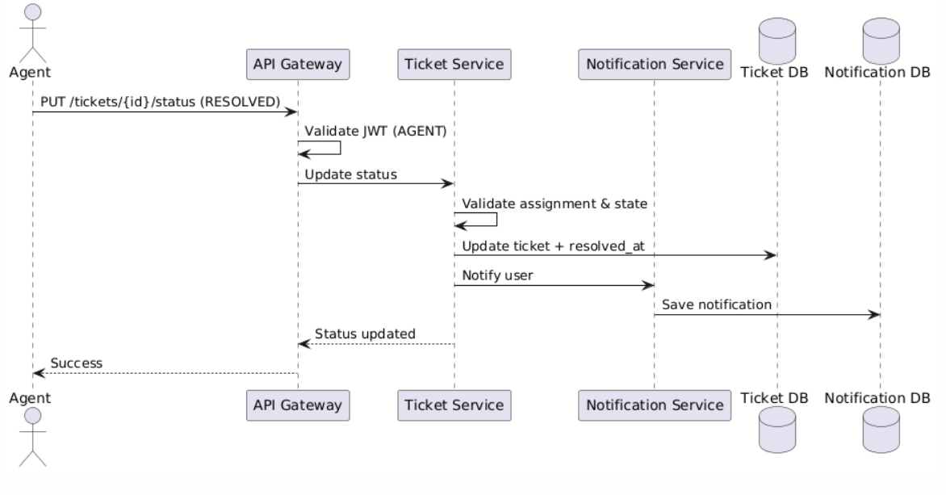

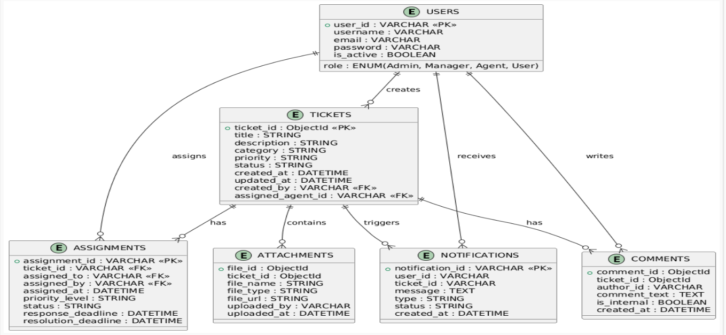

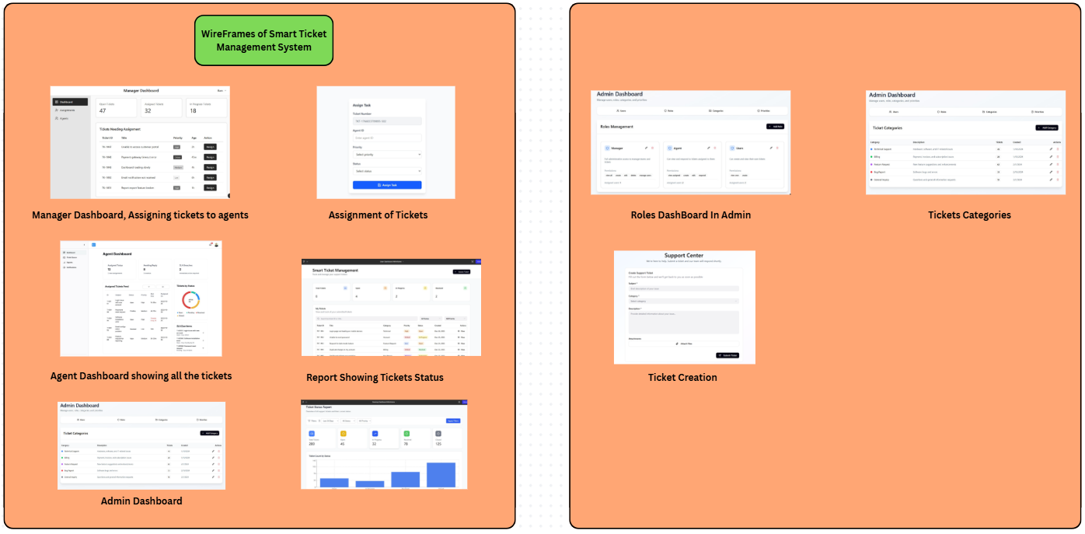

Business Rules:

### 1. Auth Service (MySQL)

These rules ensure secure access and identity integrity within the organization.

**Role Uniqueness**: Every user must be assigned exactly one role (End User, Support Agent, Support Manager, or Admin).

**Credential Security**: All passwords must be hashed using BCrypt before being stored in the MySQL database.

**Account Locking**: Users with an is_active status set to false must be denied JWT generation.

**Identity Source**: The MySQL user_id serves as the mandatory reference ID for all ticket "creator" and "assignee" fields across other services.

### 2. Ticket Service (MongoDB)

These rules govern the lifecycle of a ticket and the handling of documents.

**Lifecycle Integrity**: Tickets can only transition between statuses in a logical flow (e.g., a ticket cannot go from Created to Resolved without being Assigned or In Progress).

**Resolution Proof**: A ticket status cannot be updated to Resolved unless the Support Agent provides a resolution description or a closing comment.

**Reopening Constraints**: Only tickets in a Resolved or Closed state can be reopened.

**Attachment Ownership**: Only the original creator of the ticket or the assigned support agent/manager is permitted to upload documents to a specific ticket record.

### 3. Assignment Service (MySQL)

These rules manage workload and ensure SLA compliance.

**Exclusive Assignment**: A ticket can have only one ACTIVE assignment record at any given time to prevent coordination conflicts.

**SLA Calculation**: The resolution_deadline must be automatically calculated at the time of assignment based on the ticket's priority (e.g., 4 hours for URGENT, 48 hours for LOW).

### 4.Notification Service (MySQL)

These rules handle communication triggers.

**Event Triggering**: A notification must be generated immediately upon three primary events: Ticket Creation (to End User), Ticket Assignment (to Agent), and SLA Breach (to Manager)